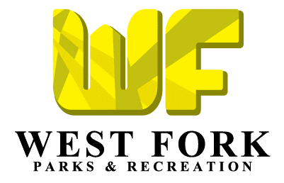
262 W. Main Street
P.O. Box 339
West Fork, AR 72774
479-839-2342
479-839-3335 (fax)

March 1, 2017,

I am writing this letter on behalf of the Parks and Recreation Department of the City of West Fork. As you may know the city’s Carter Park contains a sports complex that includes, 4 baseball\softball fields, tennis and basketball courts, pavilions and open space areas for recreational activities. The City is one of 6 cities in our county wide baseball/softball league. West Fork has a large number of participants, with over 250 kids involved in this program and the West Fork High School baseball and softball teams play their home games at our facility. Our annual Independence Day Celebration is held there, which attracts an estimated 2,000 plus people. There are many other events, tournaments, and activities that bring people to our park each year, as well as, a good number residents that visit the park daily.

The City greatly appreciates the support that it has received from the community thus far, but in order to continue to develop and maintain this extraordinary park, we need your help! One way to help is by purchasing advertisement at the park. The Parks Department is selling banners to be placed on the fences and other areas of our ballpark. The banners are 3ftx5ft and can be designed with your logo to fit your advertising needs. The cost of the banner is $150.00 per year. The money collected for these banners will go to pay for the banner itself, purchasing equipment and other items, future projects, day to day upkeep, and much more. The banners would be in place from early March through September; during the peak season for park visitors.

We would love to place a banner for you, but anything you and\or your company can donate to the park will truly make a difference and be appreciated for years to come! If there is any other information we can provide please do not hesitate to let us know. You may contact me at (479) 839-2342 or by email at parks@westforkar.gov.

Sincerely,

Chad Harrison
Parks and Recreation Director
262 W. Main Street
P.O. Box 339
West Fork, AR 72774
479-839-2342
479-839-3335 (fax)

Sponsorship Options
______ I would like to purchase a banner for the Carter Park Sports Complex ($150 per year)

*Banners are 3ftx5ft and will hang March - September*

_______ I would like to make a donation to the Parks Department in this amount
$____________

Company Name: ________________________________________________________

Contact Person: _________________________________________________________

Phone Number: _________________________________________________________

Mailing Address: _________________________________________________________

Contact Email: __________________________________________________________

*(please make checks payable to The City of West Fork)

